**Angat Nayanbhai Shah | 6th Sem | Div - C**

**AMTICS | Urvisha Patel - Phase 2**

**Compiler Craft – A Compiler Design Application**

## **Phase 1**

In Phase 1 of the Compiler Craft project, we developed the core functionality of a compiler simulation mobile application using Flutter. The app demonstrated various compilation phases such as Lexical Analysis, Syntax Analysis, Semantic Analysis, Intermediate Code Generation, Code Optimization and Code Generation. It enabled users to input expressions and visualize how they are processed through each phase, thereby enhancing conceptual understanding of compiler internals. Initial implementations focused on basic functionality, correct flow between phases and foundational accuracy. Also implemented the token classification and ambiguity checking functions.

## 

## **Phase 2**

The primary goal of Phase 2 was to enhance the application's capability and reliability. Significant improvements were made to increase the accuracy of each compilation phase. A major new feature was introduced: **nfa to dfa,** **removal of left recursion and grammar factoring**, making the syntax analysis more robust and applicable to a wider range of grammars. These upgrades not only improve parsing efficiency but also ensure better compatibility with LL(1) parsing techniques. Additionally, efforts were made to improve the internal logic and performance of the app, laying the groundwork for future compiler features.

### **Project Enhancements**

| **SR.NO** | **Features** | **Phase 1 Status** | **Phase 2 Upgrade** |
| --- | --- | --- | --- |
| 1 | Compiler Analyzer | Basic Logic | Improved accuracy |
| 2 | Lexical Analyzer | Implemented | Better Token Handling |
| 3 | Grammar Check | Implemented | Optimized code accuracy and efficiency |
| 4 | NFA to DFA | Basic UI | Implemented |
| 5 | Recur & Factor | Pending | Implemented |

**Output**

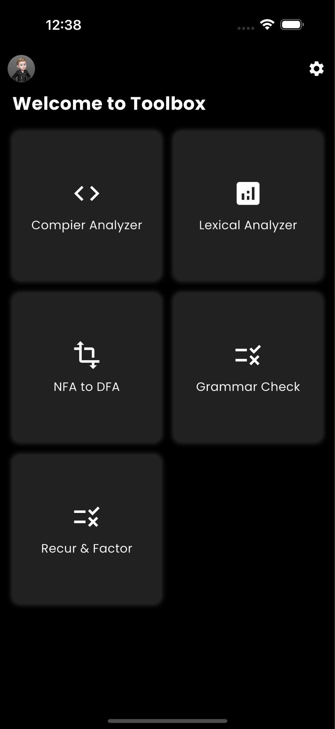 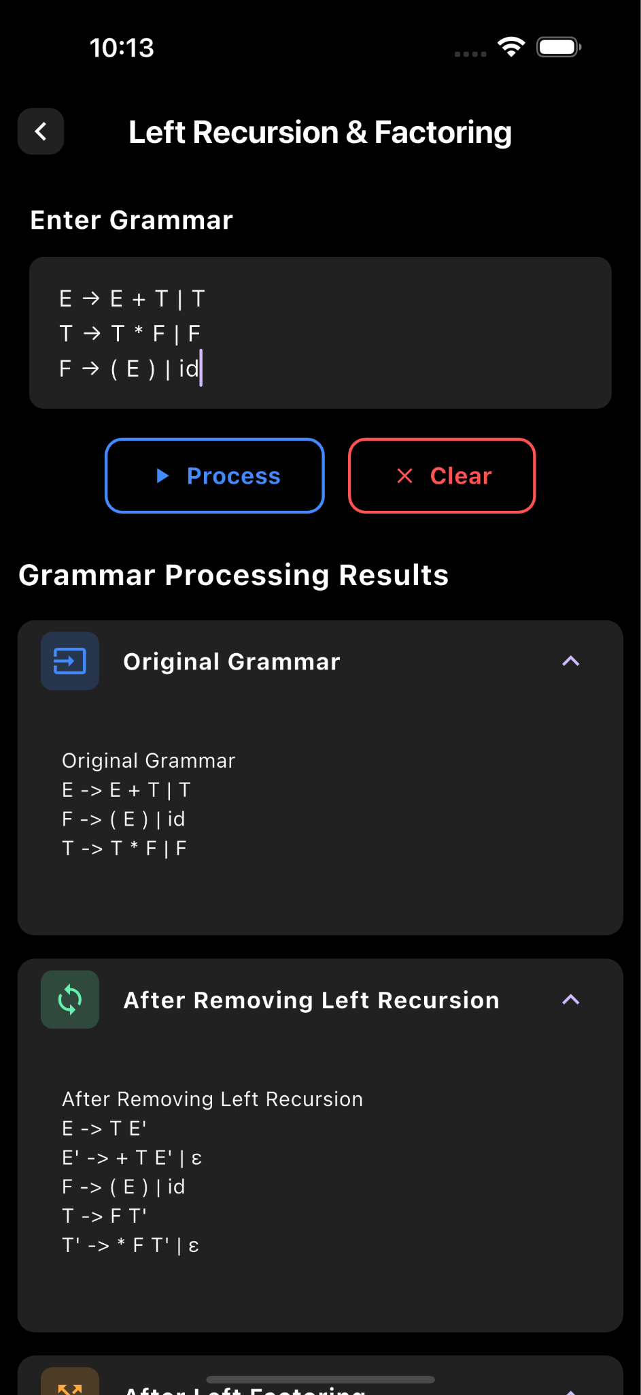 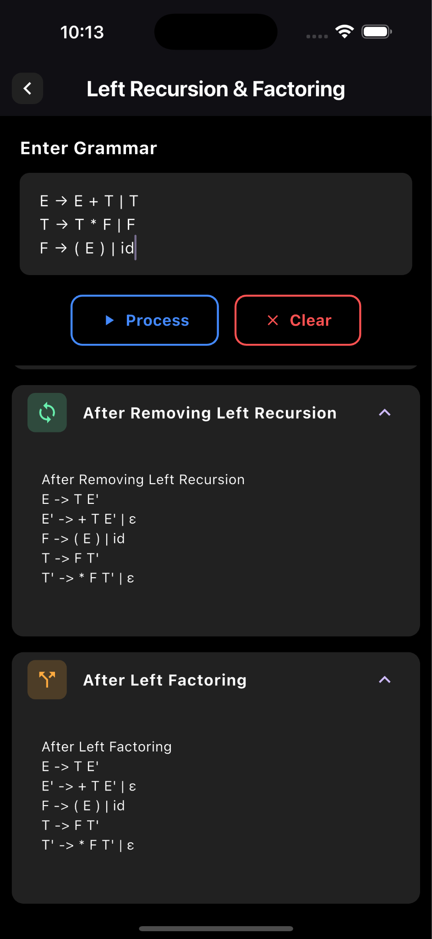

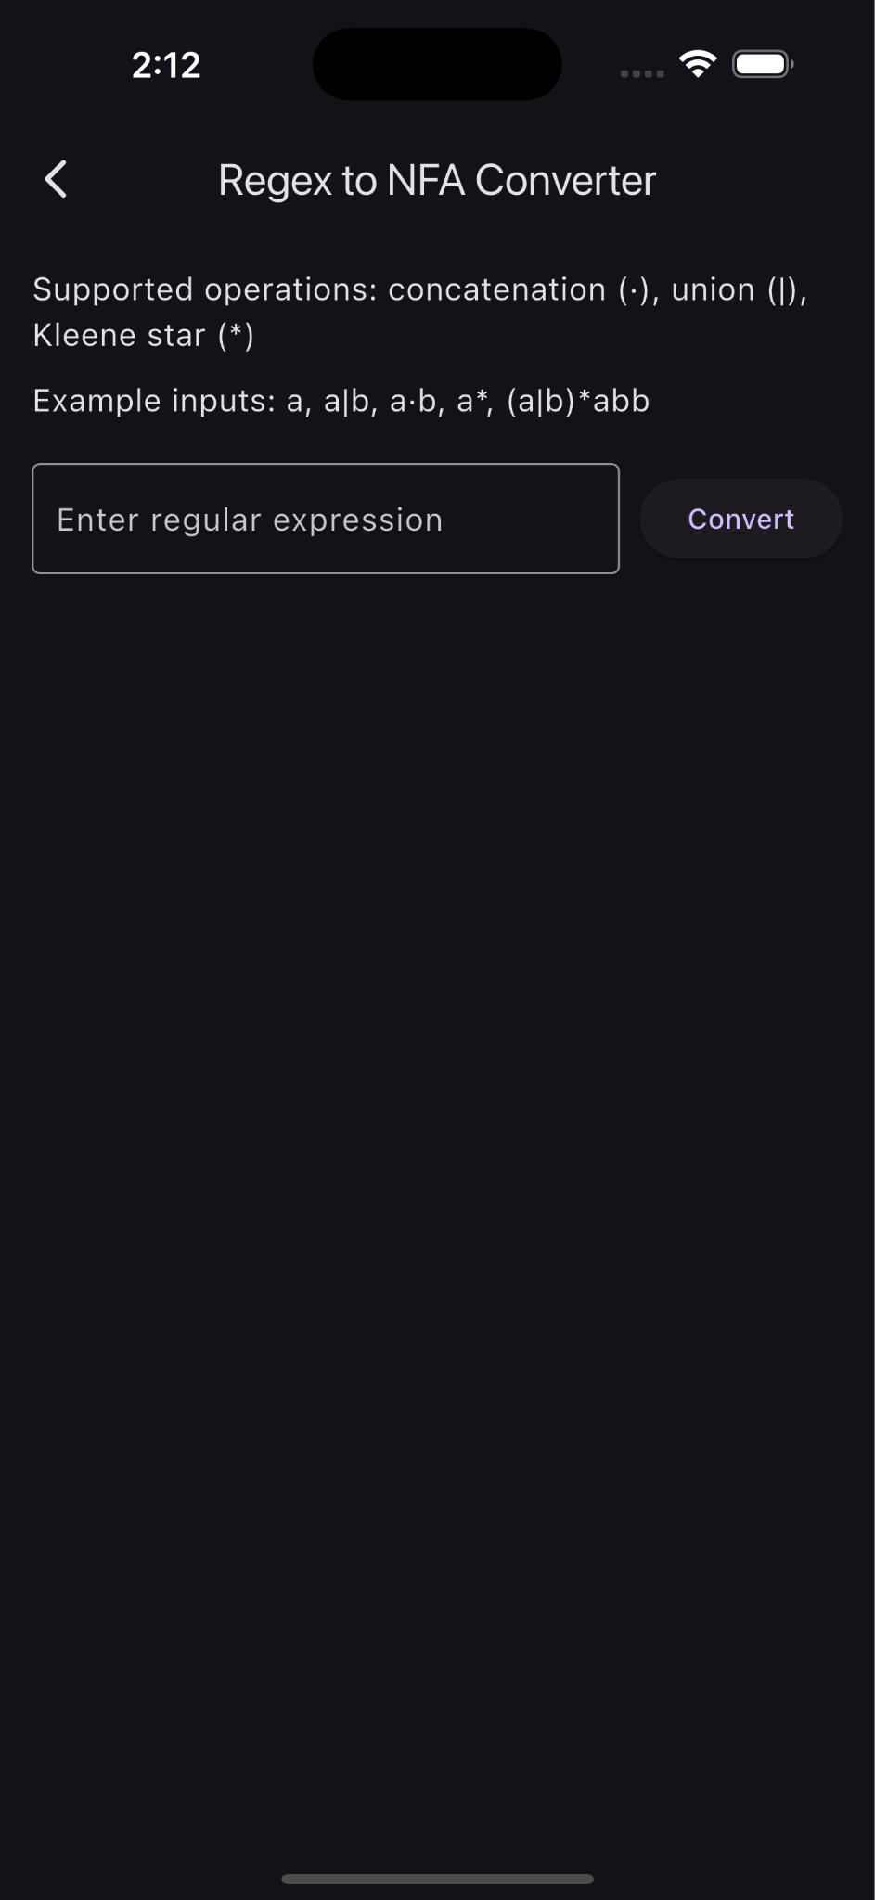 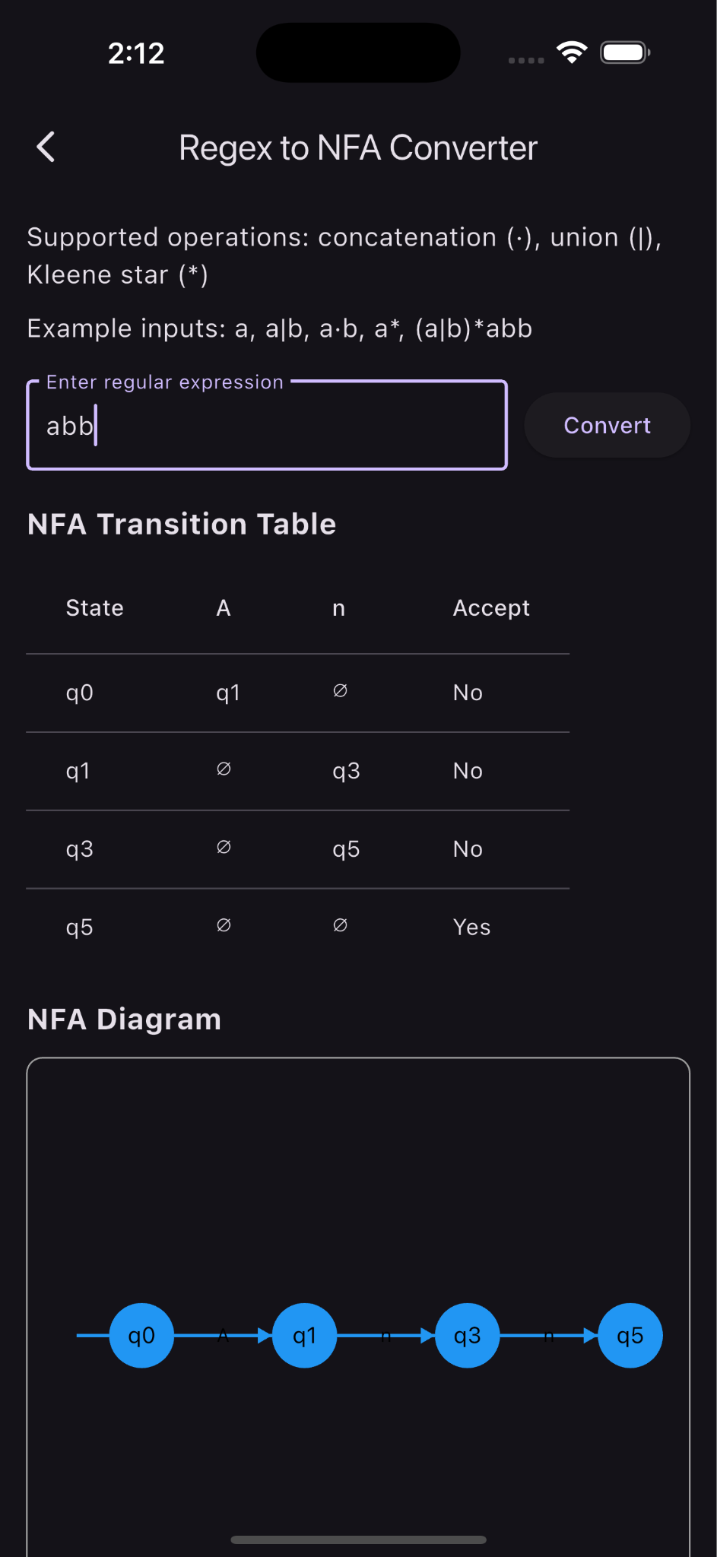

**Future Work**

* Add Detailed Explanations : Provide descriptions for each compilation phase.
* Add More Compiler Features : Implement additional algorithms for grammar and other concepts of Compiler Design.
* Add Database integration and profile customization.